**Experiment No. : 5**

**Title: Implementation of Binary Search Tree using Doubly Linked List (DLL)**

**Batch:B1 Roll No.:1914078 Experiment No.: 5**

**Aim:** Write a program for following operations on Binary Search Tree using Doubly Linked List (DLL).

1. Create empty BST,
2. Insert a new element on the BST
3. Search for an element on the BST
4. Delete an element from the BST
5. Display all elements of the BST

___________________________________________________________________________

**Resources needed:** C/C++/JAVAeditor and compiler

**___________________________________________________________________________**

**Theory**

**Binary Tree :-**

A binary tree is made of nodes, where each node contains a "left" reference, a "right" reference, and a data element. The topmost node in the tree is called the root.

Every node (excluding a root) in a tree is connected by a directed edge from exactly one other node. This node is called a parent. On the other hand, each node can be connected to arbitrary number of nodes, called children. Nodes with no children are called leaves, or external nodes. Nodes which are not leaves are called internal nodes. Nodes with the same parent are called siblings.

**Example**

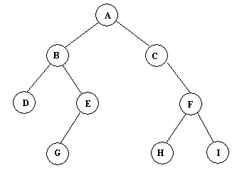

Figure(a): Binary Tree Example

**Traversals :**

A traversal is a process that visits all the nodes in the tree. Since a tree is a nonlinear data structure, there is no unique traversal. We will consider several traversal algorithms with we group in the following two kinds.

1. depth-first traversal
2. breadth-first traversal

There are three different types of depth-first traversals, :

* PreOrder traversal - visit the parent first and then left and right children;
* InOrder traversal - visit the left child, then the parent and the right child;
* PostOrder traversal - visit left child, then the right child and then the parent.

There is only one kind of breadth-first traversal--the level order traversal. This traversal visits nodes by levels from top to bottom and from left to right.

Consider an example the following tree and its four traversals:

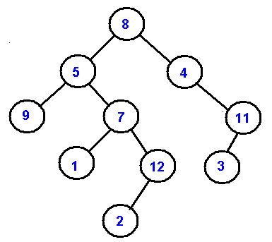

**Figure 5.3: Example of Tree Traversals**

PreOrder - 8, 5, 9, 7, 1, 12, 2, 4, 11, 3   
InOrder - 9, 5, 1, 7, 2, 12, 8, 4, 3, 11   
PostOrder - 9, 1, 2, 12, 7, 5, 3, 11, 4, 8   
LevelOrder - 8, 5, 4, 9, 7, 11, 1, 12, 3, 2

**Binary Search Tree(BST):** It is a binary tree where elements are stored in a particular order of left child is less than the parent and parent is less than the right child. This small modification makes BST efficient for searching. It is also called as BST property.

**Example of BST** following fig is the example BST whose root is 8 and follows the BST property.

## http://staff.ustc.edu.cn/%7Ecsli/graduate/algorithms/book6/247_a.gif

## Methods for storing binary trees

Binary trees can be constructed from programming language primitives in several ways.

### Nodes and references

In a language with records and [references](https://en.wikipedia.org/wiki/Reference_%28computer_science%29), binary trees are typically constructed by having a tree node structure which contains some data and references to its left child and its right child. Sometimes it also contains a reference to its unique parent. If a node has fewer than two children, some of the child pointers may be set to a special null value, or to a special [sentinel node](https://en.wikipedia.org/wiki/Sentinel_node).

Binary Search Tree can be implemented as a linked data structure in which each node is an object with two pointer fields. The two pointer fields *left and right* points to the nodes corresponding to the left child and the right child NULL in any pointer field signifies that there exists no corresponding child.

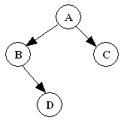 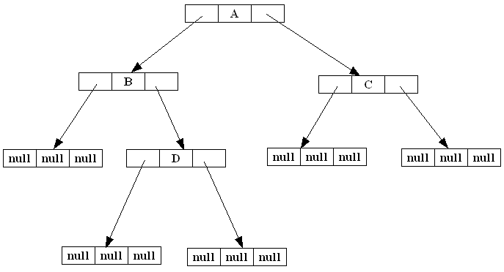

Figure : Binary Search Trees example

**___________________________________________________________________________**

**Algorithm :**

**1. createBST()** – This function should create a ROOT pointer with NULL value as empty BST.

**2. insert( typedef newelement )** – This void function should take a newelement as an argument to be inserted on an existing BST following the BST property.

**3. typedef search(typedef element )** – This function should search for specified element on the non-empty BST and return it.

**4**. **typedef delete(typedef element)** – This function searches for an element and if found deletes it from the BST and returns the same.

**5**. **typedef getParent(typedef element)** - This function searches for an element and if found, returns its parent element.

**6. DisplayInorder( )** – This is a void function which should go through non- empty BST, traverse it in inorder fashion and print the elements on the way.

_________________________________________________________________________________

**NOTE : All functions should be able to handle boundary(exceptional) conditions.**

**Activity:** Write pseudocode for each method and implement the same.

**Results:** A program depicting the correct behaviour of BST and capable of handling all possible exceptional conditions and the same is reflecting clearly in the output.

**____________________________________________________________________________**

**Program :**

#include <stdio.h>

#include <stdlib.h>

struct node

{

    int data;

    struct node *left;

    struct node *right;

}*root,*pnode,*dnode,*rnode;

int flag=0; //GLOBAL VARIABLE

// ---------------------Functions---------------------

void createBST(){

    root=NULL;

}

struct node *newNode(int item)

{

    struct node *temp =  (struct node *)malloc(sizeof(struct node));

    temp->data = item;

    temp->left = temp->right = NULL;

    return temp;

}

void inorder(struct node *root)

{

    if (root != NULL)

    {

        inorder(root->left);

        printf("%d \n", root->data);

        inorder(root->right);

    }

}

struct node* insert(struct node* node, int data)

{

    if (node == NULL) return newNode(data);

    if (data < node->data)

        node->left  = insert(node->left, data);

    else if (data > node->data)

        node->right = insert(node->right, data);

    return node;

}

int search(int val)

{

    pnode= NULL;

  if(root!=NULL){

        dnode = root;

        while(dnode!=NULL){

            if(dnode->data > val){

                pnode = dnode;

                dnode = dnode->left;

            }else if(dnode->data < val){

                pnode = dnode;

                dnode = dnode->right;

            }else if(dnode->data == val){

                flag=1;

                break;

            }

        }

        if(flag==1){

            return 1;

        }else{

            return 0;

        }

    }else{

        return -1;

    }

}

void delete(int val){

    if(search(val)==1){

        // ------------Leaf node------------

        if(dnode->left==NULL && dnode->right==NULL){

            if(pnode==NULL){

                root = NULL;

                // free(dnode);

            }

            else if(pnode->left == dnode)

                pnode->left = NULL;

            else if(pnode->right == dnode)

                pnode->right = NULL;

            free(dnode);

        }

        // -----------One child node----------

        else if(dnode-> left !=NULL && dnode-> right ==NULL){

            if(pnode==NULL){

                root = dnode-> left;

                // free(dnode);

            }

            else if(pnode->left == dnode)

                pnode->left = dnode-> left;

            else if(pnode->right == dnode)

                pnode->right = dnode-> left;

            free(dnode);

        }

        else if(dnode-> left ==NULL && dnode-> right !=NULL){

            if(pnode==NULL){

                root = dnode->right;

                // free(dnode);

            }

            else if(pnode->left == dnode)

                pnode->left = dnode-> right;

            else if(pnode->right == dnode)

                pnode->right = dnode-> right;

            free(dnode);

        }

        // ------------2 child node------------

        else if(dnode-> left !=NULL && dnode-> right !=NULL){

            struct node *min =  (struct node *)malloc(sizeof(struct node));

            min = dnode->right;

            while(min->left!=NULL){

                rnode = min;

                min = min->left;

            }

            dnode->data = min->data;

            if(min->right!=NULL){

                rnode->left = min->right;

            }

            free(min);

        }

        printf("\nThe value deleted is : %d",val);

    }else if(search(val)==0){

        printf("\nElement not found");

    }else{

        printf("\nEmpty BST");

    }

}

void getParent(int val){

    if(root->data==val){

        printf("\nThis is the root node");

    }

    if(search(val)==1){

        printf("\nThe parent node is : %d",pnode->data);

    }

}

int main()

{

    root=NULL;

    int ch=0;

    int ele,val;

    printf("\n======= Binary Search Trees Implementation =======\n");

    while (ch != 7)

    {

        printf("\n\n1. Create a BST");

        printf("\n2. Insert");

        printf("\n3. Search");

        printf("\n4. Delete");

        printf("\n5. Get Parent element");

        printf("\n6. Display inorder elements");

        printf("\n7. Exit");

        printf("\nEnter your choice from 1-7: ");

        scanf("%d", &ch);

        switch (ch)

        {

        case 1:

            createBST();

            printf("\nNew BST created");

            break;

        case 2:

            printf("\nPlease enter element: ");

            scanf("%d",&ele);

            root=insert(root,ele);

            printf("\nElement inserted");

            break;

        case 3:

            printf("\nPlease enter element to be searched: ");

            scanf("%d",&ele);

            val = search(ele);

            if(val==0)

            {

                printf("\nElement not found");

            }

            else if(val==1){

                printf("\nElement found");

            }else{

                printf("\nEmpty BST");

            }

            break;

        case 4:

            printf("\nPlease enter element to be deleted: ");

            scanf("%d",&ele);

            delete(ele);

            break;

        case 5:

            printf("\nPlease enter child element to be searched: ");

            scanf("%d",&ele);

            getParent(ele);

            break;

        case 6:

            if(root==NULL){

                printf("\nEmpty BST");

            }else{

                inorder(root);

            }

            break;

        default:

            printf("\nEnter your choice from 1-7 only");

            break;

        }

    }

    printf("\nThank you");

    return 0;

}

**Output:-**

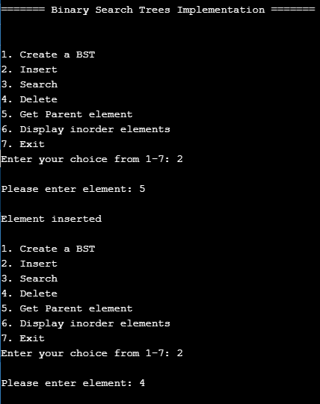

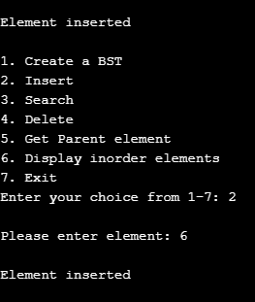

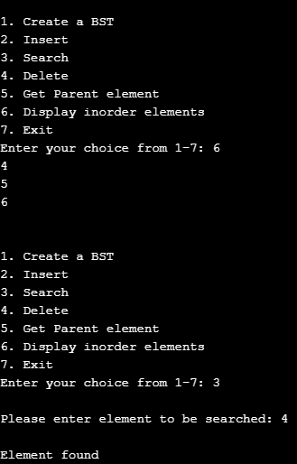

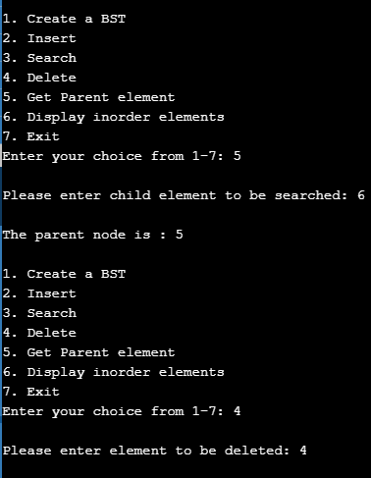

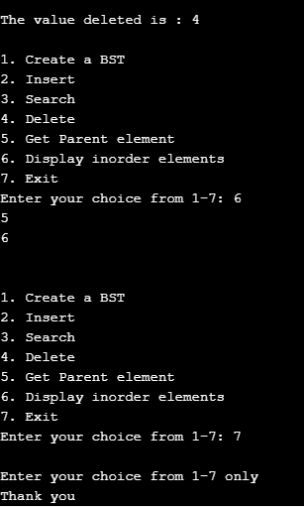

**PseudoCode:-**

**void createbst():-**

     root=NULL;

**Void insert(struct,data):-**

if (node == NULL) return newNode(data)

if (data < node->data)

node->left = insert(node->left, data)

else if (data > node->data)

node->right = insert(node->right, data)

return node

Void search():-

pnode= NULL

if(root!=NULL)

dnode = root

while(dnode!=NULL)

if(dnode->data > val)

pnode = dnode

dnode = dnode->left

else if(dnode->data < val)

pnode = dnode

dnode = dnode->right

else if(dnode->data == val)

flag=1

break

if(flag==1)

return 1

else

return 0;

else

return -1

Void delete():-

if(search(val)==1)

// Leaf node

if(dnode->left==NULL && dnode->right==NULL)

if(pnode==NULL)

root = NULL

else if(pnode->left == dnode)

pnode->left = NULL

else if(pnode->right == dnode)

pnode->right = NULL

free(dnode)

// One child node

else if(dnode-> left !=NULL && dnode-> right ==NULL)

if(pnode==NULL)

root = dnode-> left

else if(pnode->left == dnode)

pnode->left = dnode-> left

else if(pnode->right == dnode)

pnode->right = dnode-> left

free(dnode)

else if(dnode-> left ==NULL && dnode-> right !=NULL)

if(pnode==NULL)

root = dnode->right

else if(pnode->left == dnode)

pnode->left = dnode-> right

else if(pnode->right == dnode)

pnode->right = dnode-> right

free(dnode)

// 2 child node

else if(dnode-> left !=NULL && dnode-> right !=NULL)

struct node *min = (struct node *)malloc(sizeof(struct node))

min = dnode->right

while(min->left!=NULL)

rnode = min

min = min->left

dnode->data = min->data

if(min->right!=NULL)

rnode->left = min->right

free(min);

// print The value deleted is : val

else if(search(val)==0)

// print Element not found

else

print Empty BST

**Int search(num):-**

pnode= NULL

if(root!=NULL)

dnode = root

while(dnode!=NULL)

if(dnode->data > val)

pnode = dnode

dnode = dnode->left

else if(dnode->data < val)

pnode = dnode

dnode = dnode->right

else if(dnode->data == val)

flag=1

break

if(flag==1)

return 1

else

return 0

else

return -1

**Void inorder(struct *root)**:-

if (root != NULL)

inorder(root->left)

// print root->data

inorder(root->right)

voi**d getParent(int val):-**

if(root->data==val)

// print This is the root node

if(search(val)==1)

// print The parent node is : pnode->data

**Outcomes:** CO2 Apply linear and non-linear data structure in application development

**Conclusion: We successfully used our knowledge of DLL and Binary Search Trees to perform functions on BST and receive correct outputs.**

.

**Grade: AA / AB / BB / BC / CC / CD /DD**

**Signature of faculty in-charge with date _____________________________________________________________________________**

**References:**

**Books/ Journals/ Websites:**

* Y. Langsam, M. Augenstin and A. Tannenbaum, “Data Structures using C”, Pearson Education Asia, 1st Edition, 2002.